Part 1: Biomechanics Vocabulary
Directions: Each box in the table below contains an important biomechanics term. For each term, sketch a diagram to show its mean and write a brief definition/description.
Abduct |  | Adduct | Extension | Flexion
Dorsal |  | Ventral | Distal | Proximal
Bone |  | Ligament | Tendon | Muscle
Supination (Supine) | Pronation (Pronate)
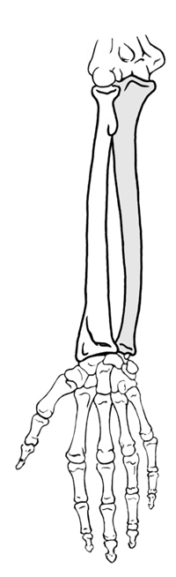
Forearm (Ventral)
Directions: On the
diagram, label the
bones of the
forearm and hands.
Anatomy in Clay: Building the Musculature of a Human Hand
Part 2: Anatomy of a Human Hand
Directions: On the diagram below, use colored pencils to sketch in muscles, tendons and ligaments that are key to hand mechanics.

PALM (ventral-side)
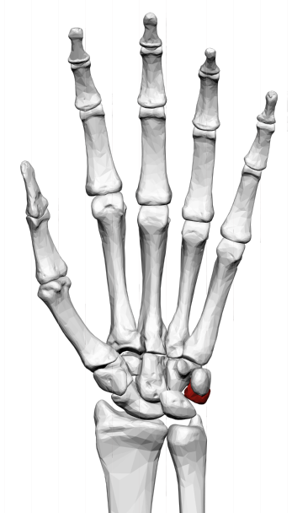

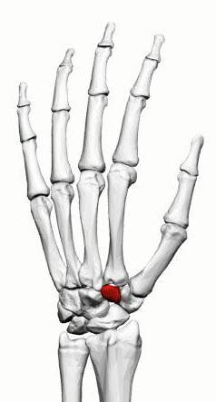
DORSAL (back of hand)

