BONES AS LEVERS AND JOINTS AS FULCRUMS
So, what do torques and rotation have to do with building a prosthetic hand?
In our body, our BONES are rigid bodies that act as LEVERS. Levers are a type of simple machine—a machine to help make work easier.
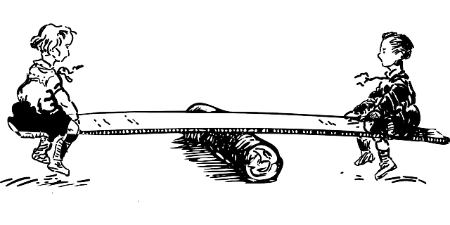
A lever is a rigid body that rotates or pivots around a fulcrum (axis of rotation). A classic example of a lever is teeter totter (see image below). Engineers actually sort levers into three classes (types).
Effort (applied force)
Load (Resisting force)
Fulcrum (Axis of Rotation)

Sketch the “Classes of Levers” organizer in your notebook. Use the web links to complete the “classes of levers” graphic organizer (below), and then answer the questions.
Link 1: http://www.technologystudent.com/forcmom/lever1.htm
Link 2: http://waergo.com/JES/BodyBasics.htm#Lev
Link 2: http://www.slideshare.net/lenfaunk/joint-biomechanics (begin on slide #12)
CLASSES OF LEVERS
 | CLASS 1 | CLASS 2 | CLASS 3
Description
Sketch
Real-life Examples
Example(s) in the Body

Q1: What is a lever?
Q2: What is the purpose of a fulcrum?
Q3: How are levers used within the body?
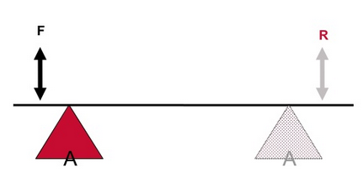
Q4: Think about Class I levers. In which of the following cases will the person need to apply the LEAST force in order to produce a torque? Explain your reasoning.
A B
C

